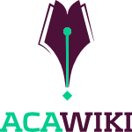

Press Release Title

Cambridge, MA — Thursday, 16 June 2011 - This is a release

A quote is good. We are using Droid Serif Free Font.

Some more details.

Another quote.

More details.

For More Information
- http://acawiki.org

About AcaWiki

AcaWiki is like "Wikipedia for academic research" designed to collect summaries and literature reviews of peer-reviewed academic research, and make them available to the general public. AcaWiki is a 501(c)(3) nonprofit organization with seed funding from the Hewlett Foundation. We've just launched, and there are lots of ways to communicate about the site.

Press Contact

- Please contact press@acawiki.org

Press Kit

- http://acawiki.org/about

